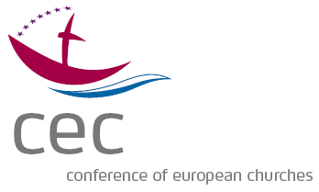

REGISTRATION FORM
Turn it up!
Amplifying the Christian Voice in a Secular Europe
20 to 22 September 2017
Paris, France
Please return this complete form to Maura O’Riordan mor@cec-kek.be no later than 15 July 2017.

Contact Info

First name: Family name or surname:

Title (Mr / Ms / Rev / Dr) :

Postal address:

Telephone number:

Email address:

Church or organisation you represent:

Social Media

Please identify the social media accounts you will be using throughout the conference. These may be personal or corporate accounts and will be shared with other conference participants. Hashtags will be established closer to the conference.

Twitter:

Facebook:

Other:

Finances

The registration fee for the conference is € 100 and includes meeting facilities, all meals and coffee breaks from lunch on 20 September to lunch on 22 September, and an evening supper and boat cruise on the Seine. Instructions on how to pay the registration fee and a proposal for accommodation is included in the invitation letter.

Participants are expected to cover their travel costs and to make their own travel arrangements. If you require financial support to attend, please contact the Conference of European Churches before making travel arrangements.

I shall require subsidies for:

Travel costs: YES / NO
If yes, please indicate exact amount in euros:

Accommodation: YES / NO

Travel

Means of transport (e.g., flight, train):
Arrival airport or station (e.g., Charles de Gaulle, Gare du Nord) :

Arrival date: Time: Flight or train number:
Departure date: Time: Flight or train number:

Accommodation

Please reserve a room for me at Hotel Axel Opéra: YES / NO

I shall need accommodation for the nights of:

20 to 21 September: YES / NO
21 to 22 September: YES / NO

Dietary requirements

I have special dietary requirements: YES / NO
If yes, please specify:

Visa and Insurance (for participants from outside the EU)

I need health insurance to cover medical treatment in France: YES / NO
I need a visa to enter France: YES / NO*
*If YES, please provide your date of birth, permanent address, nationality, passport or ID card number, and official name on your passport or ID card.

