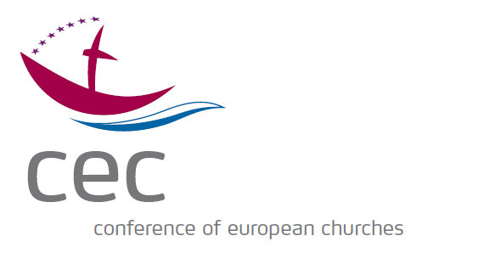
Conference of European Churches

Assembly Planning Committee

Brussels, Belgium – 19-20 February 2018
Participants List

Assembly Planning Committee:
Ms Nan Braunschweiger, Church of Scotland
Ms Satu Koikkalainen, Evangelical Lutheran Church in Finland
Rev. Canon Dr Leslie Nathaniel, Church of England
Rev. Helle Rosenkvist, Evangelical-Lutheran Church of Denmark
OKR Klaus Rieth, Evangelical Lutheran Church in Württemberg
Very Rev Archimandrite Ignatios Sotiriadis, Orthodox Church of Greece
Ms Elena Timofticiuc, Romanian Orthodox Church
Ms Catherine Tsavdaridou, Ecumenical Patriarchate

Apologies:
Mr Michael Bubik, Evangelical Church A.C. in Austria
Bishop Christopher Hill, Church of England (CEC President)
H.E. Archbishop Dr Yeznik Petrosyan, Armenian Apostolic Church

Guest:
Mr Andreas Henriksen Aarflot, Church of Norway (CEC Governing Board)
Rev. Dr Patrick Roger Schnabel, Berliner Missionswerk

Staff:
Ms Charlotte Belot, Assistant
Mr Danilo Mihajlovic, Local Coordinator
Very Reverend Protopresbyter Heikki Theodoros Huttunen, General Secretary
Mr Szabolcs Lörincz, Assembly Coordinator

Status 14 February 2018

